Use Case Realisation Report (Analysis) - Update Profile
FOR
Volunteer Management System
(VMS)

CLIENT
PROJECT | Volunteer Management System (VMS)Volunteer Management System
TITLE | Use Case Realisation Report (Analysis) - Update Profile
VERSION | 0.3a0.2a
DATE | 13-Aug-2011
 | ORIGINATOR
 | Name / Signature | Team 8S
 | APPROVAL
 | Name / Signature | Phung Kim Cuong, Dio
Institute of Systems Science |  | Document Reference
25 Heng Mui Keng Terrence  Singapore 119615 |  | VMS/T-1.4.1/1

 | Acceptance
 | Customer Signature |  | Customer Signature
 | Name & Designation |  | Name & Designation
 | Date & Company Stamp |  | Date & Company Stamp

Revision History

Date | Version | Description | Author
12-Jun-2011 | 0.1a | Creation | Team 8S
12-Aug-2011 | 0.2a | Updates | Team 8S
12-Aug-2011 | 0.3a | Updates | Team 8S

Table of Contents

1. Brief Description 3
2. Flow of Events 3
Standard Flow 3
2.1 3
2.2 Exceptions 4
3. Interaction Diagrams 5
3.1 Collaboration Diagram for Update profile 5
4. Participating Objects 5
4.1 User 5
4.2 UserProfileScreen 5
4.3 NAVMenu 5
4.4 HomeScreen 6
4.5 MainController 6
4.6 UserController 6
Class Diagram 6
5. 6
ANNEX D Amendment History 7

Use Case Realisation Report (Analysis) - Update Profile

Brief Description
The use case enables registered User to update his/her profile.

Flow of Events
The standard flow of events for this use case and any exceptions are described in the following subsections. See section 3 for an overview of the participating Actors and Domain Objects.

Standard Flow
Precondition: User has logged in the system.
This use case provides the user interface related functionality that will be provided to the User, as follows:
- When the User clicks ‘Update Profile’ link on the HomeScreen, the method HomeScreen.updateProfile() will be triggered and it will use MainController.redirectURL() method to redirect to UserProfileScreen.
- The MainController.redirectURL() will use the UserProfileScreen.show() method to display a input form enabling the User to edit personal info
- UserProfileScreen.show() will fetch the user details by calling the method UserController.getUserDetails()
- The UserProfileScreen.show() method will use User.getUserFullName()/Nationality/DOB/Gender/LaunguageProficiency/Profession/Contact/Address to populate User detailed information on the screen.
- The User can edit following info:
- Full Name
- Nationality
- Date of Birth
- Gender
- Language Proficiency
- Profession
- Contact
- Address
- When user click ‘Update’ button, The UserProfileScreen .onSubmit() method will be triggered and it will use UserProfileScreen.validateFormat() method to perform basic format checking.
- After checking is done, the UserProfileScreen will use the UserController .updateUserProfile() method to update the user info by calling User.update() .

- UserController.updateUserProfile() will use the UserProfileScreen.displayMsg() method to display a confirmation message to User.
- The use case terminates.

Exceptions
The following exceptions have been identified:
- Invalid Information Format. If any of inputs information is incompatible, system will display a validation summary for user to make amendments.

Interaction Diagrams

Collaboration Diagram for Update profile
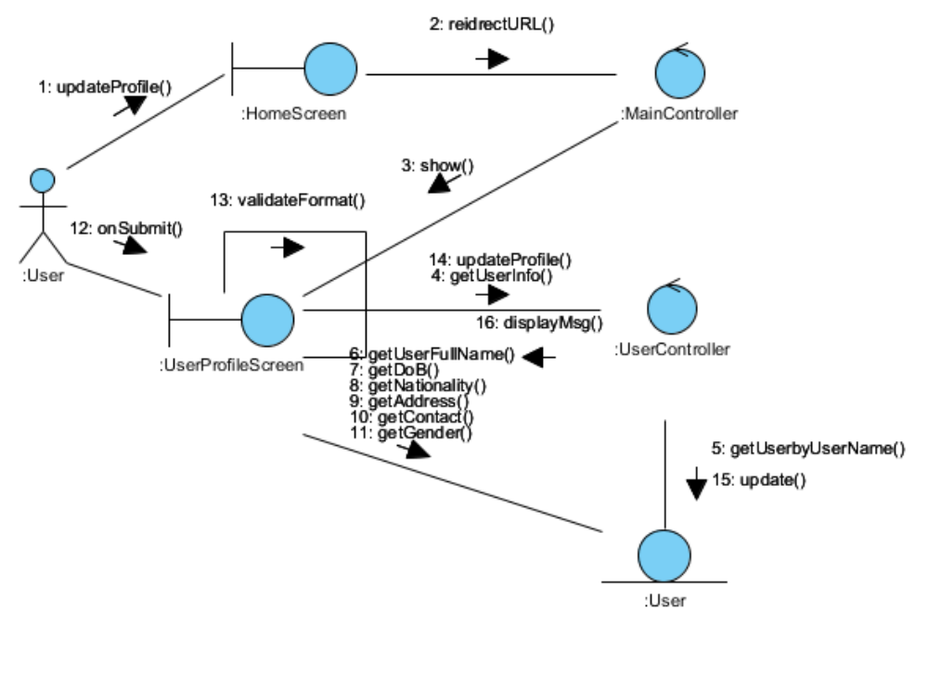
Figure 1 – Collaboration Diagram for Update Profile

Participating Objects

User
This entity object stores the details concerning a user of the volunteer organisation. The primary attribute that it holds is the userID.

UserProfileScreen
This boundary object is used to display user profile info and allow user to edit the profile information.

.

HomeScreen
This boundary object is used for redirecting and displaying of home screen details and menu. All the user actors use this object.

MainController
This control object co-ordinates the menu selection and dispatches of requests of the volunteer management system. It delegates the user requests to the specific use case control objects for carrying out the use cases.

UserController
This control object co-ordinates the user information update, creation and retrieval.

Class Diagram
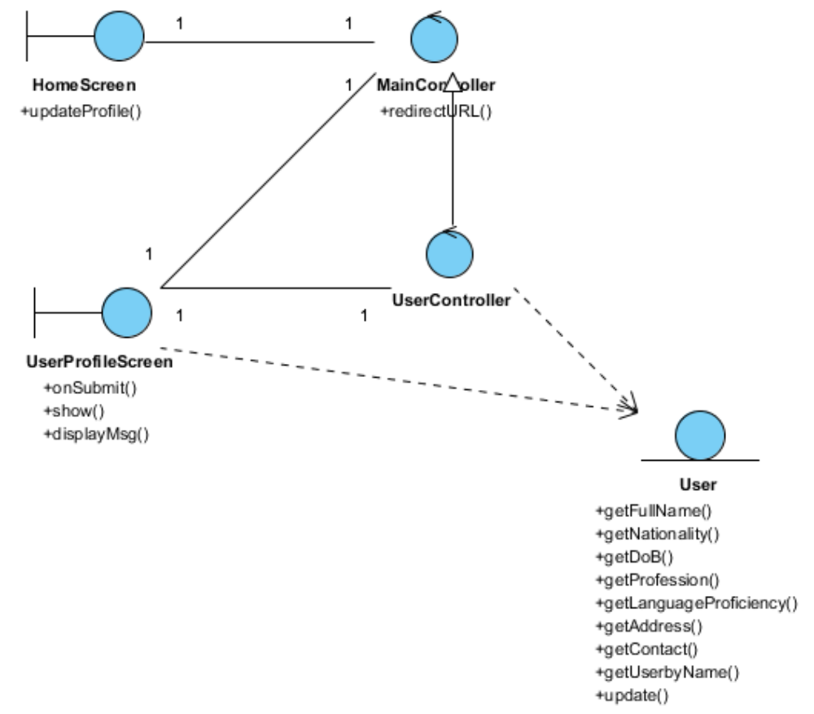
Figure 2 – Class Diagram

ANNEX D Amendment History

This is a record of all amendments made to the Document.
Version | Chapter / Section | Page No | Notes of Amendments or Changes

